 Basics of Making Good Grass Silage
- Practical Issues of silage making
The goals of making good quality silage from high quality forage are rapid preservation-for maximising recovery of nutrients and minimising spoilage organisms and good ‘shelf life’- for aerobic stability, minimising heating and spoilage on feed out.
Pre silaging Checklist – be ready!
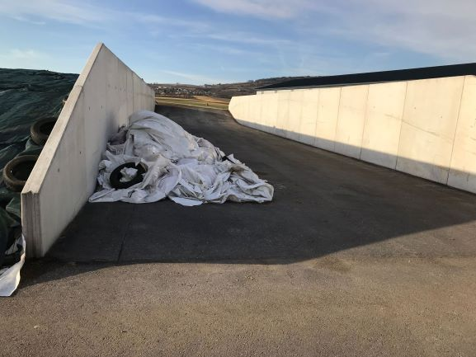
Clean and repair the pit. Remove rotting or moulding silage and check clamp walls are impermeable to air. Check the effluent channels are clear and remove/replace broken tyres that may contaminate silage with wire. Check gateways and ensure they are in good condition and not muddy. Walk fields and remove obstacles that could damage machinery. Flatten mole hills but remember late rolling will reduce yields.
Service machinery, clean additive barrels and calibrate applicator.
Take a fresh grass analysis near to your proposed cutting date. This will give you a good idea of the Dry Matter to plan wilting and also an indication of nutritional qualities of the grass including Nitrate level. Remember when sampling, not to touch the grass with your hands as sweat can be as source of Nitrate. Ideally Nitrate Nitrogen should be below 0.1%. High Nitrate N will reduce sugars and increase silage pH by ammonia production (which acts as an Alkali) possibly making silage less stable. My recommendations for farms with high Nitrate N would be to leave a long stubble and make a drier silage (but you will need an additive that gives aerobic stability).
Cutting
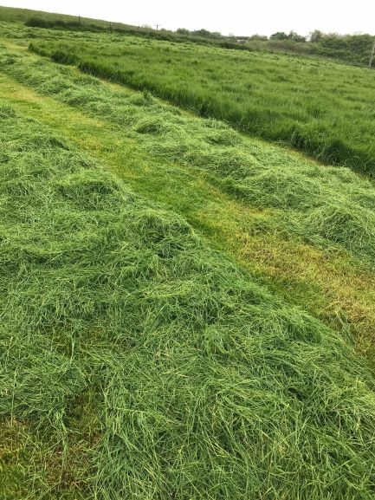
Cutting date is an important decision. Grass should be cut at the correct stage when grass is young and leafy. With a 1st cut you should try to achieve quality over yield. Often you will get bulk and protein from later cuts. D (digestible)-value and ME (energy) will decrease as grass matures. Young leafy grass could be 70%+ D- Value, grass stems thickening/lengthening 67% D- value and when flowering heads appear 65% D- value. With maturing of grass that is heading D-Value and protein could fall by 0.5%/day.
Ideally cut grass after midday - plant sugars are higher in the afternoon and are needed for a successful fermentation. Cutting height in ideal conditions could be >5cms. Leave a longer stubble (10 cms) if conditions are not ideal (soil/manure contamination, wet conditions, new leys, dead grass, High Nitrate –Nitrogen). Long stubble encourages re-growth for subsequent cuts which may be in better silaging conditions.
Wilting
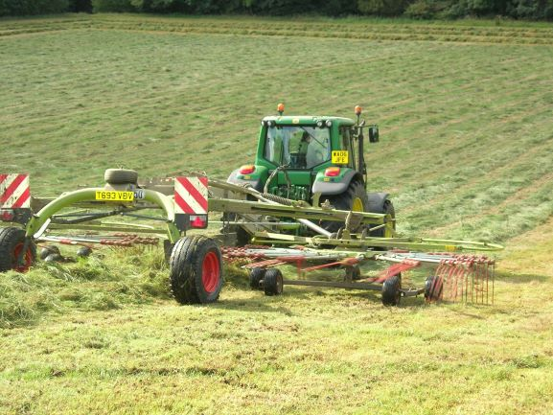
Aim to increase Dry Matter of the grass by 10%- ideally targeting a final DM of 28%.
A rapid wilt will:
-Concentrate grass sugars allowing a quick and effective fermentation.
- Reduces effluent (18% DM 150 litres/T, 25% DM 25 litres/T, 30% DM 0 litres/T).
- Reduces losses. Wilting inactivates undesirable bacteria (i.e. Clostridia) and reduces plant respiration.
- Improve animal performance with greater intake and higher Fermentable energy.
Spread grass rapidly to encourage wilting. When grass is cut the grass tries to stop water loss by closing its stomata. This is a small hole that opens and closes in the plant to allow intake of carbon dioxide and the release of oxygen & water. The fastest wilt will be achieved if the grass is spread quickly after cutting. Grass is capable of losing 100 litres of water/T 1-2 hours after cutting but will decreases to 20 litres/ T 4-5 hrs later. Mower conditioners will increase the wilt by up to 20%. Wilting rates are up to 2.5 times greater in average sunshine compared to a dull day and a spread crops wilts at twice the rate of a single row.
Over wilting (>35% DM) will make silages difficult to compact and be prone to aerobic instability. They will become less digestible and field DM losses and nutrient losses will increase. Aim for a quick wilt and try to achieve your target DM within 24 hrs. Beware of dry conditions as a much shorter wilt time will be required.
Tedding and Raking
Set up correctly to avoid ground contact. Contamination will spoil silage. Row up just before pick up. Wet grass will heat if left in rows overnight.
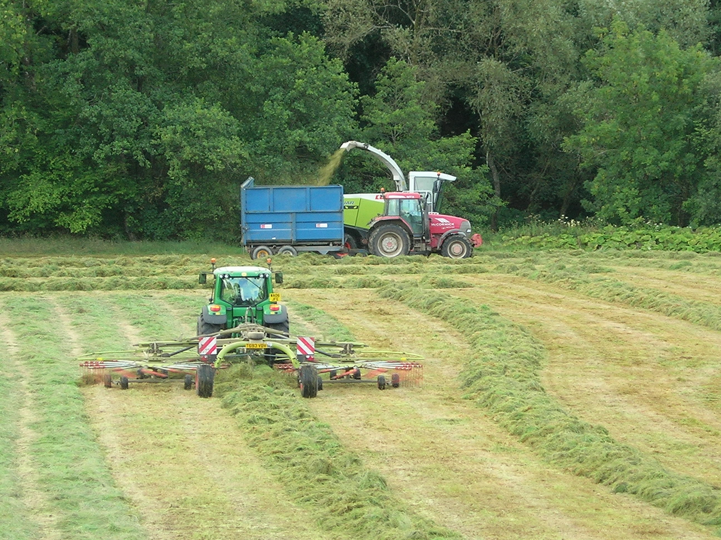

Estimating Pasture Dry Matter
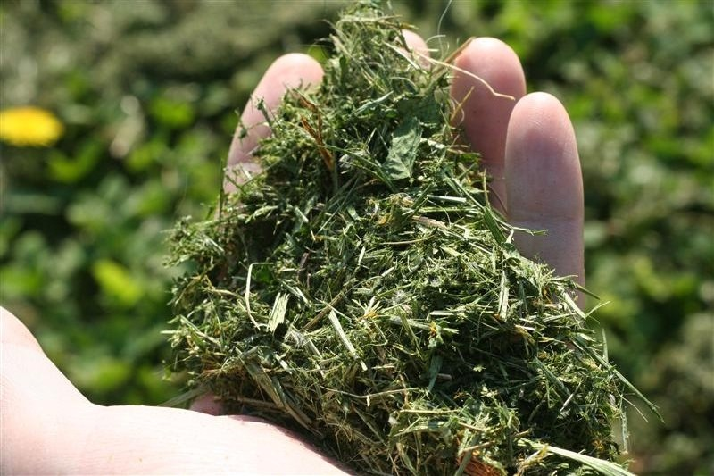 | ESTIMATED DRY MATTER %
Juice runs out easily | 18-20%
A little juice runs out with difficulty | 20-25%
Your hand is damp & sample stays in a ball when you stop squeezing | 25-30%
Sample does not stay in a ball when you stop squeezing | Over 30%

Dry matter is a difficult thing to judge in the field. One method is to use the ‘Microwave test’ (See Maize section). A quicker on the spot method is to use a squeeze test. Cut grass into 2-3 cm lengths and roll into a ball twice the size of a golf ball. Squeeze in your fist for 30 seconds. See table

Chop Length
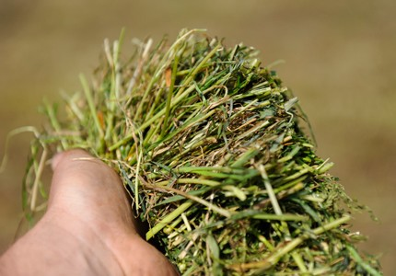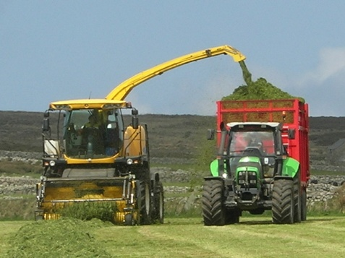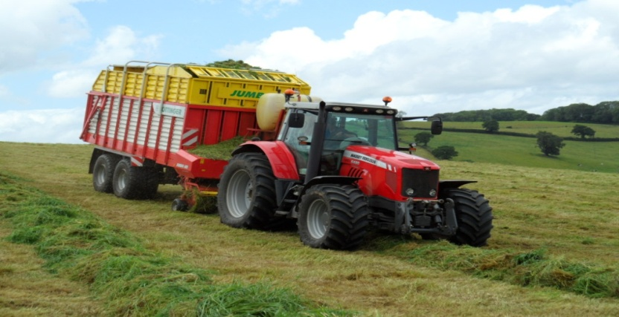

Chop length has an impact on feeding potential and compaction. It should be adjusted to Dry matter and the optimum is 15-35mm for 25-40%DM and 30-50mm for less than 25%DM.
A shorter chop length: advantages are that it leads to a more efficient fermentation with better compaction – especially in higher DM silages. You can achieve higher intakes as it is more palatable and more easily digested in the rumen. Disadvantages are that you reduce fibre for good rumen function and possibly increase effluent. A longer chop has advantages in that it provides good structural fibre for rumen function and helps reduce effluent in wet silages. The disadvantages are less compaction and poorer fermentation especially in high DM silages. Forage wagons have been a popular tool in recent years. Please bear in mind the long chop of these machines requires more emphasis on compaction. It is difficult to buck rake in thin layers.

Clamp filling.

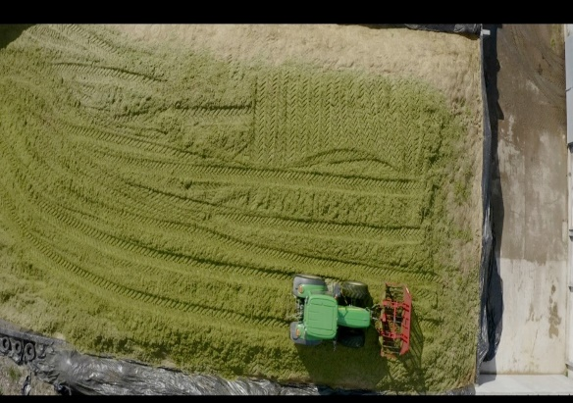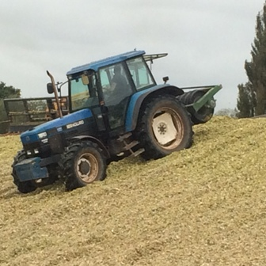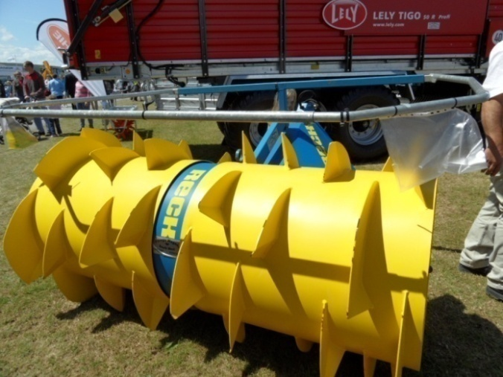
Buckraking- key to making good silage Silage compactor Silage spreader

Grass should be filled in the clamp in thin layers (20-30 cms) and in high DM silage even thinner to aid compaction. Make sure the grass is tipped across different area of the clamp face so compaction is even. Make your clamp ramp slightly concave (saucer shape) to aid tractor wheels to compact close to walls. Keep tractor/tailer tyres and tipping area clean. The use of silage compactors and grass spreader will increase compaction. The better you compact the silage the more air (oxygen) is removed and your anaerobic fermentation (desirable) will be enhanced. Avoid excess rolling on top layers or rolling the clamp next day pre sheeting. This can act as a bellows sucking air into the top layers. If you fill next day make sure it’s with a good layer of fresh cut grass.
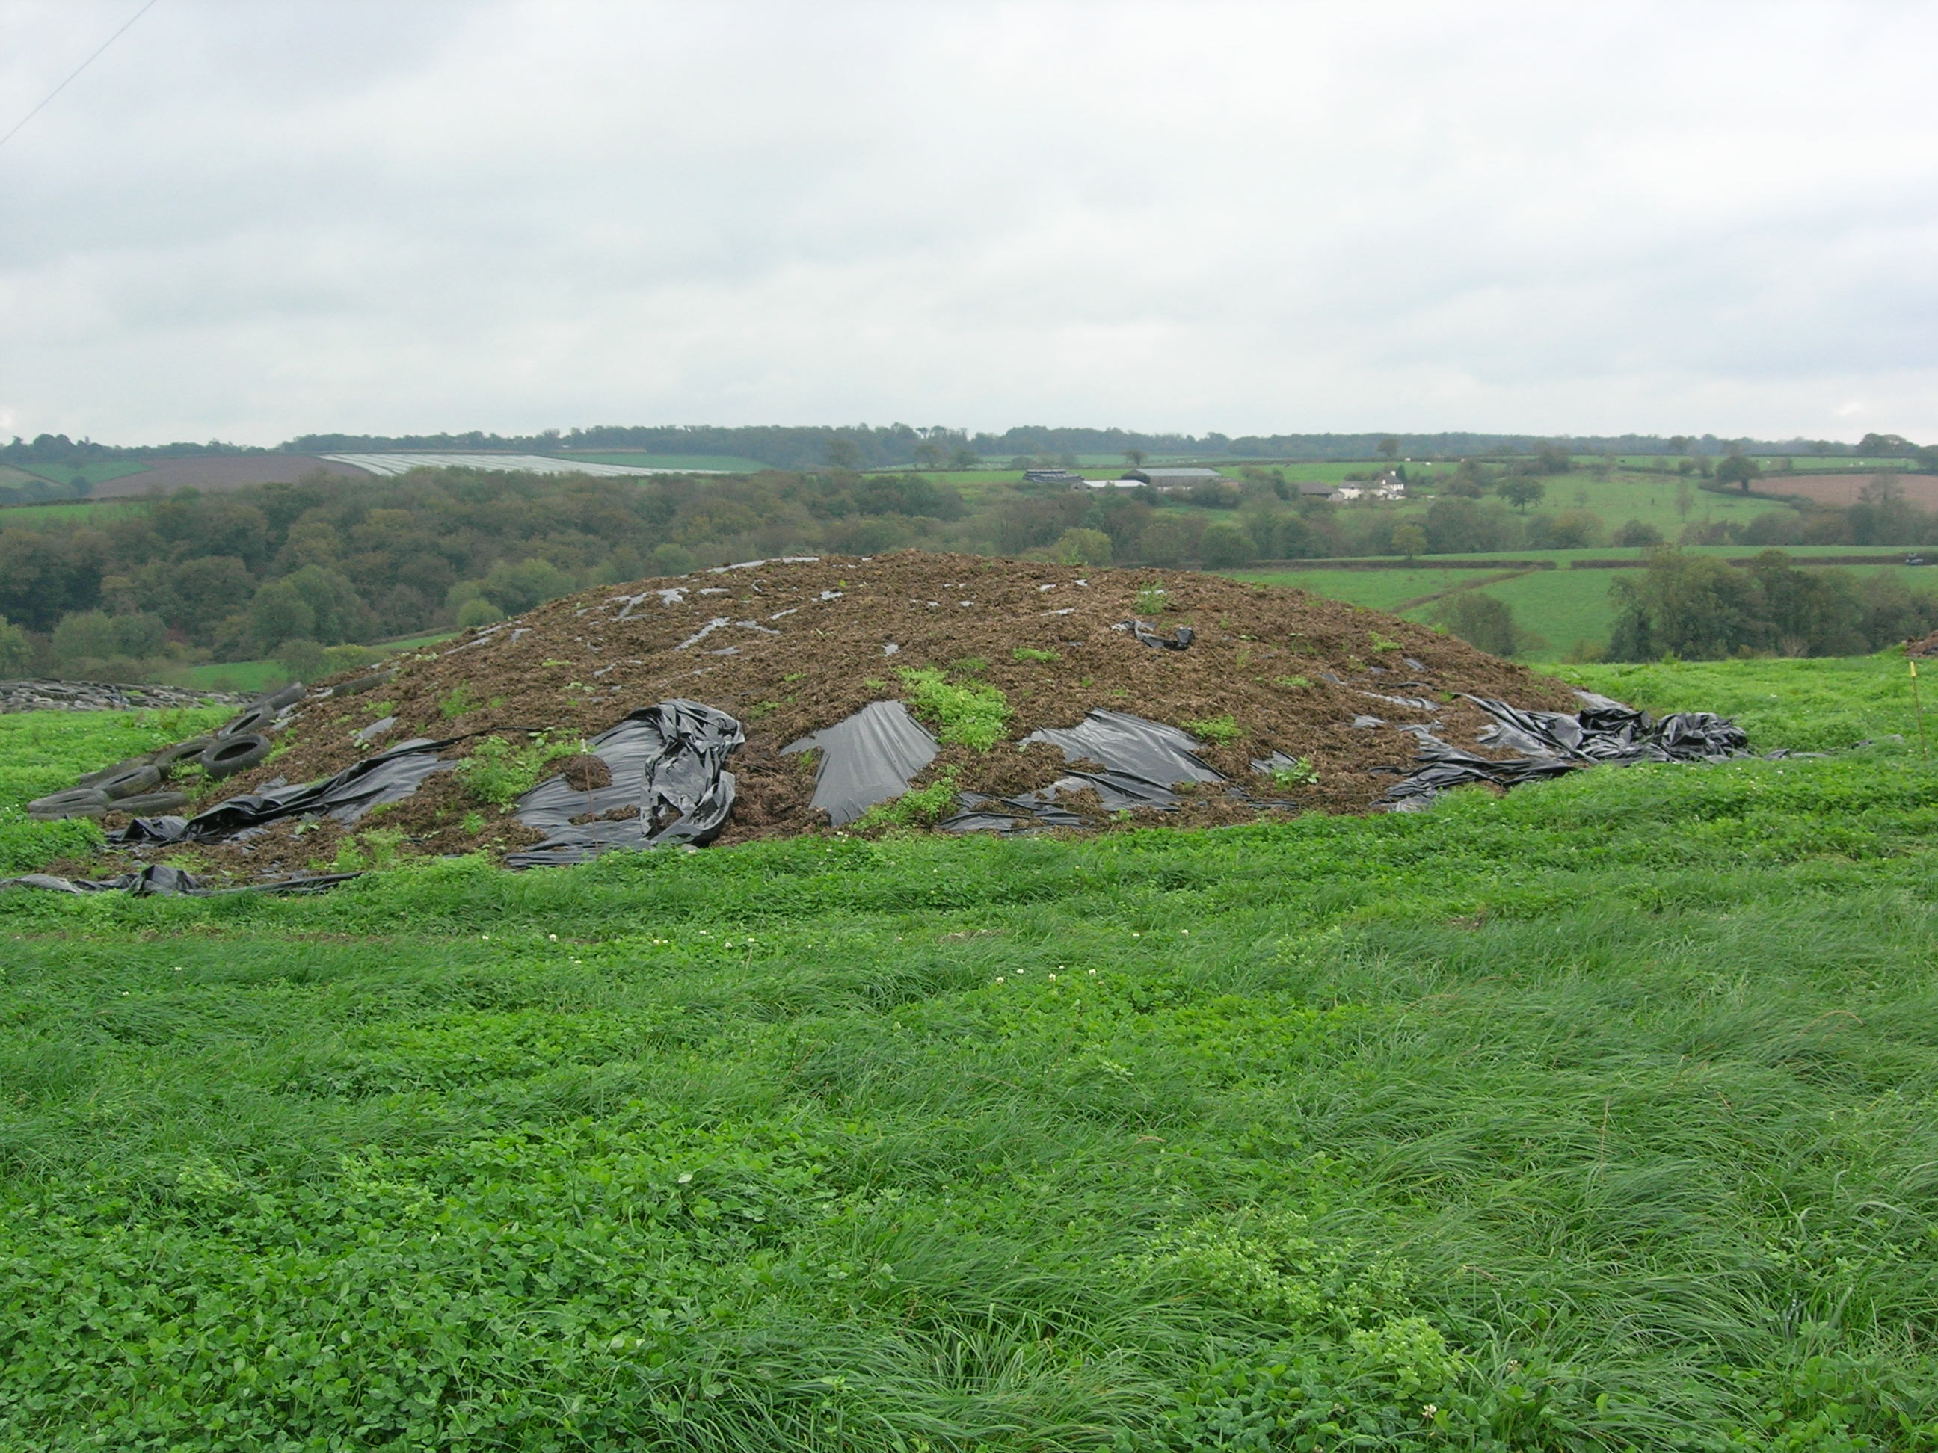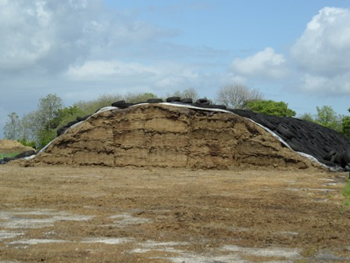
Clamp with dung capping Clamp with cling film/heavy weighted sheet

When there is no room in the clamps for excess silage you could consider a ‘German style’ Clamp. You will require a large standing area that allows the clamp to be to be bucked raked side to side. The clamp isn’t steep which allows for a better compaction. You should use weighted sheets and as much weight as possible. You will need to use a cling film under layer, silage sheet and a heavier weighted mesh sheet. Particular attention needs to be given to the ramp which is all round the clamp. Make sure it is airproofed and sealed. Loose house dung is a useful tool. The picture above shows a clamp on grass. This farmer spread dung onto the top sheet and sprinkled grass seed over it allowing it to be removed easily in sections. Clever thinking!

Sheeting Clamp & Weighting
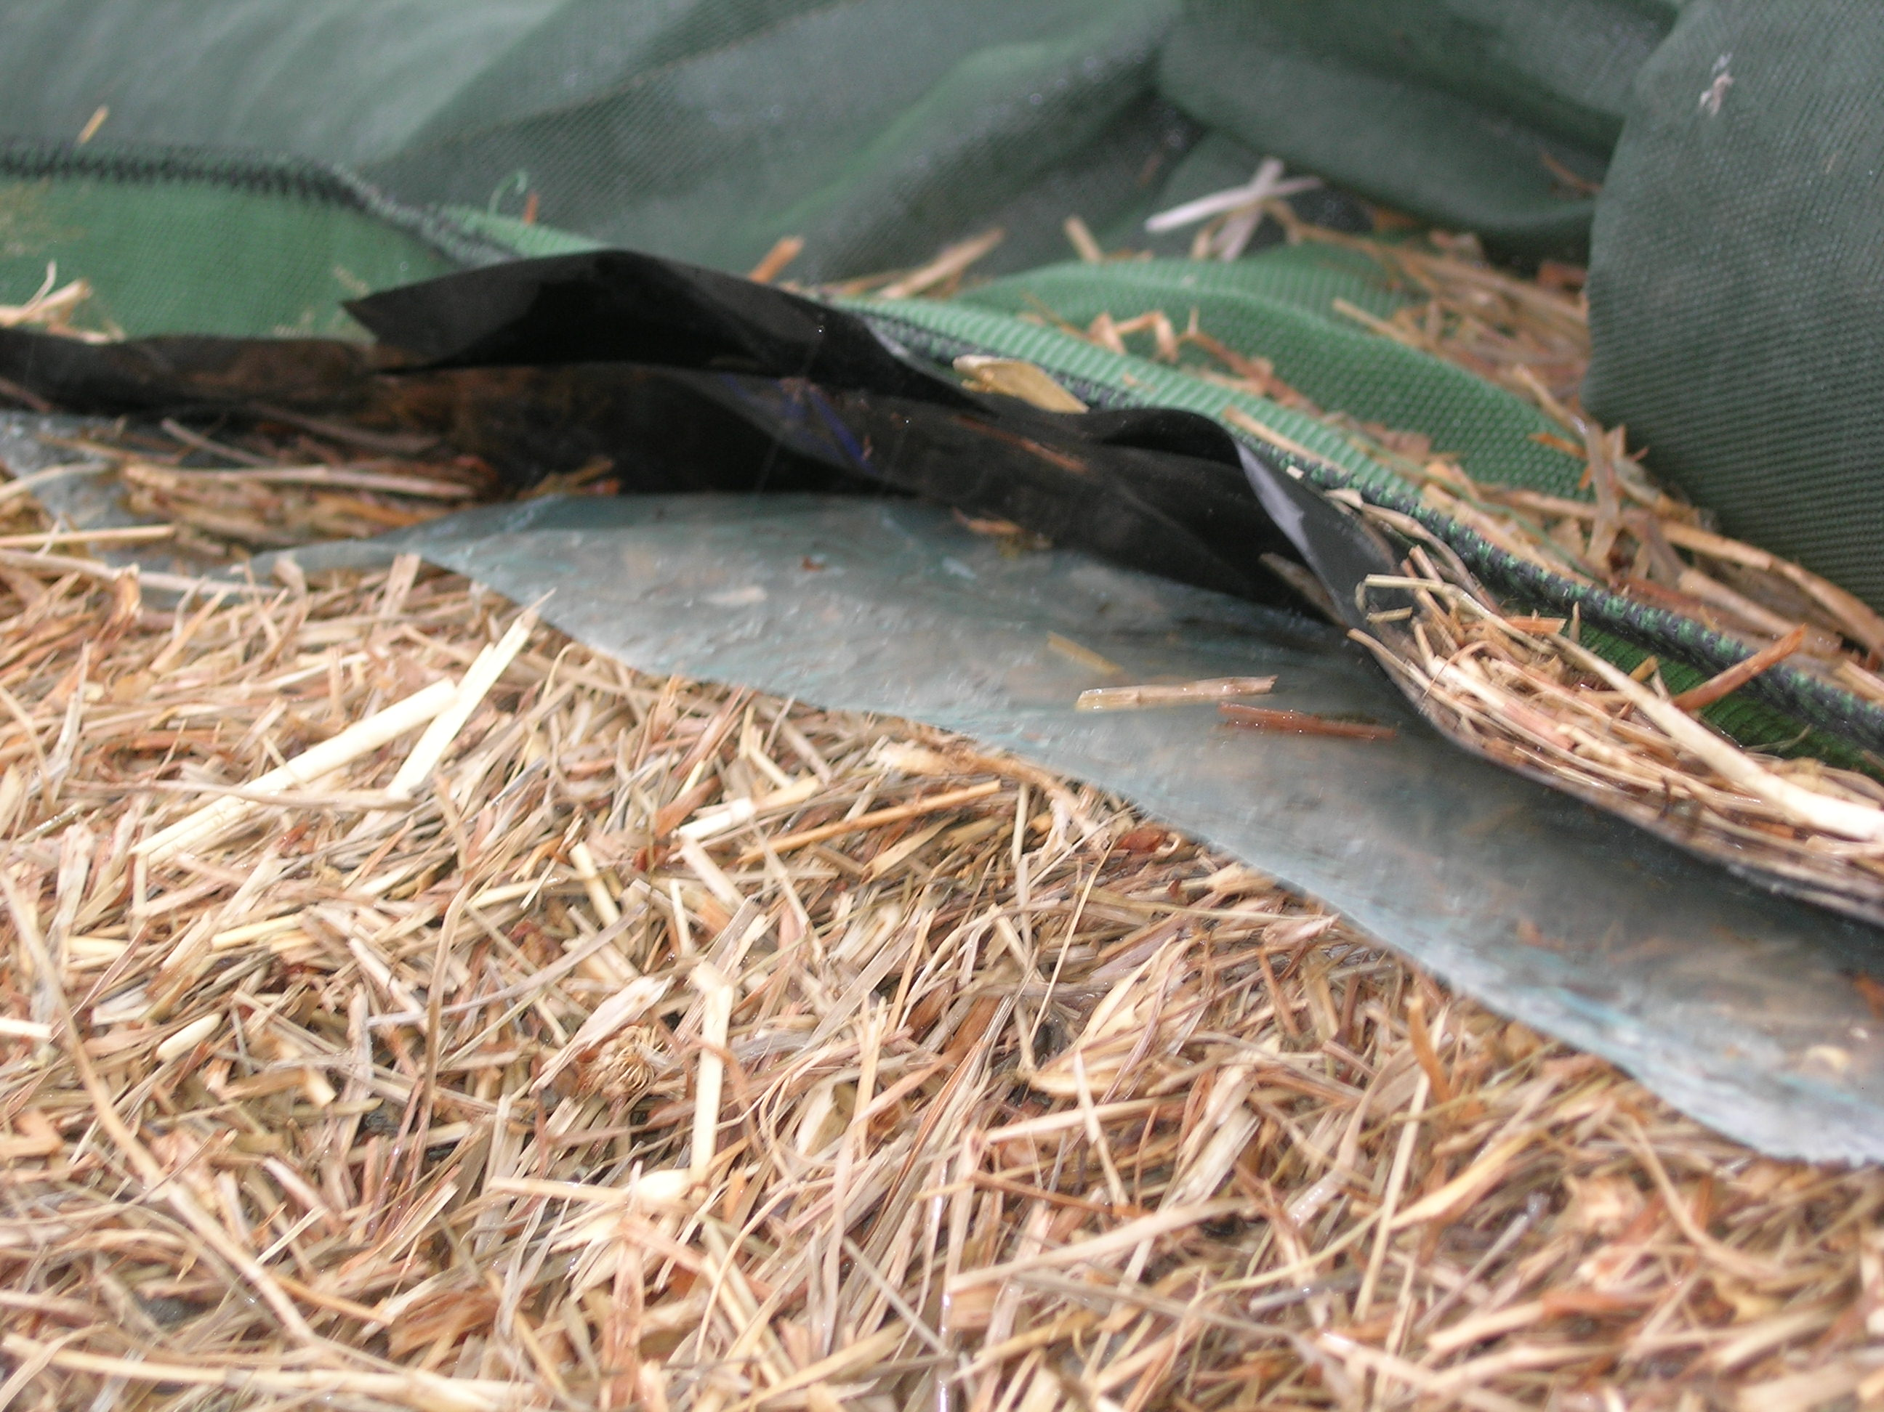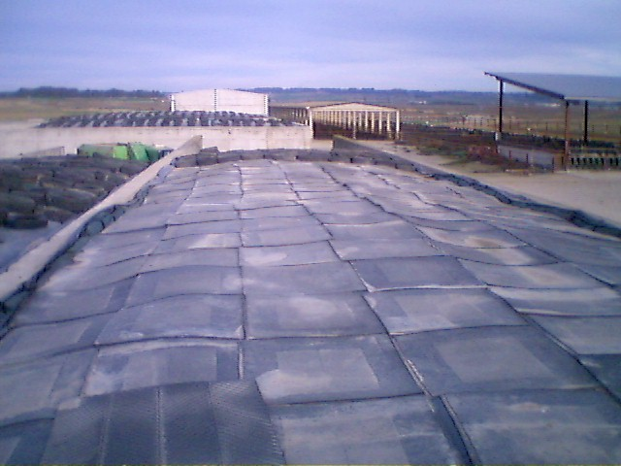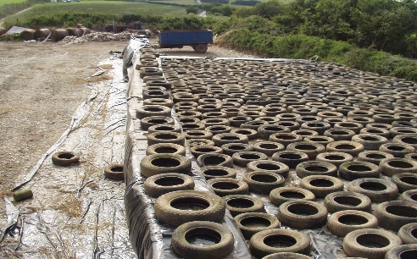
Cling film with weighted sheet Weighted mats Tradition Tyre weighting

Seal the clamp as soon as rolling has finished. It’s a good idea to sheet overnight if the job isn’t finished. Just pull sheet over clamp and temporarily fix. I know this is inconvenient but air will compromise the fermentation -attention to detail pays! Side sheet clamps to stop air ingression through sides and if you can use a cling film under sheet it will make your clamp much more airproof. If you use a cling film you will get far better results sealing the edges with weight or burying the cling film into the shoulders. You may experience the fermentation gasses raising the top sheet but it will draw down and seal every undulation. Without ‘sealing’ the cling film edges the gasses pass out the sides and the seal and draw down is not as effective. Weight the clamp to aid consolidation in the top layer. Keep an eye out for holes and repairs. Some clamps may need netting to reduce bird damage. Clamps need to be closed for approximately 6 weeks to allow consolidation and complete fermentation. Early opening of clamps can cause losses if the fermentation isn’t complete. If you need to open early try to reduce the size of clamp face so you can remove more material daily. In summer months ideally remove > 30 cm daily and in winter months 15-20 cm daily. Remember to pay particular attention to the clamp ramp which is prone to air ingression and spoilage. Don’t make it too steep that weight cannot be applied. Seal the bottom with weight or loose house dung. With earth bank clamps make sure the edges are smooth and free from vermin holes. See bad examples below!

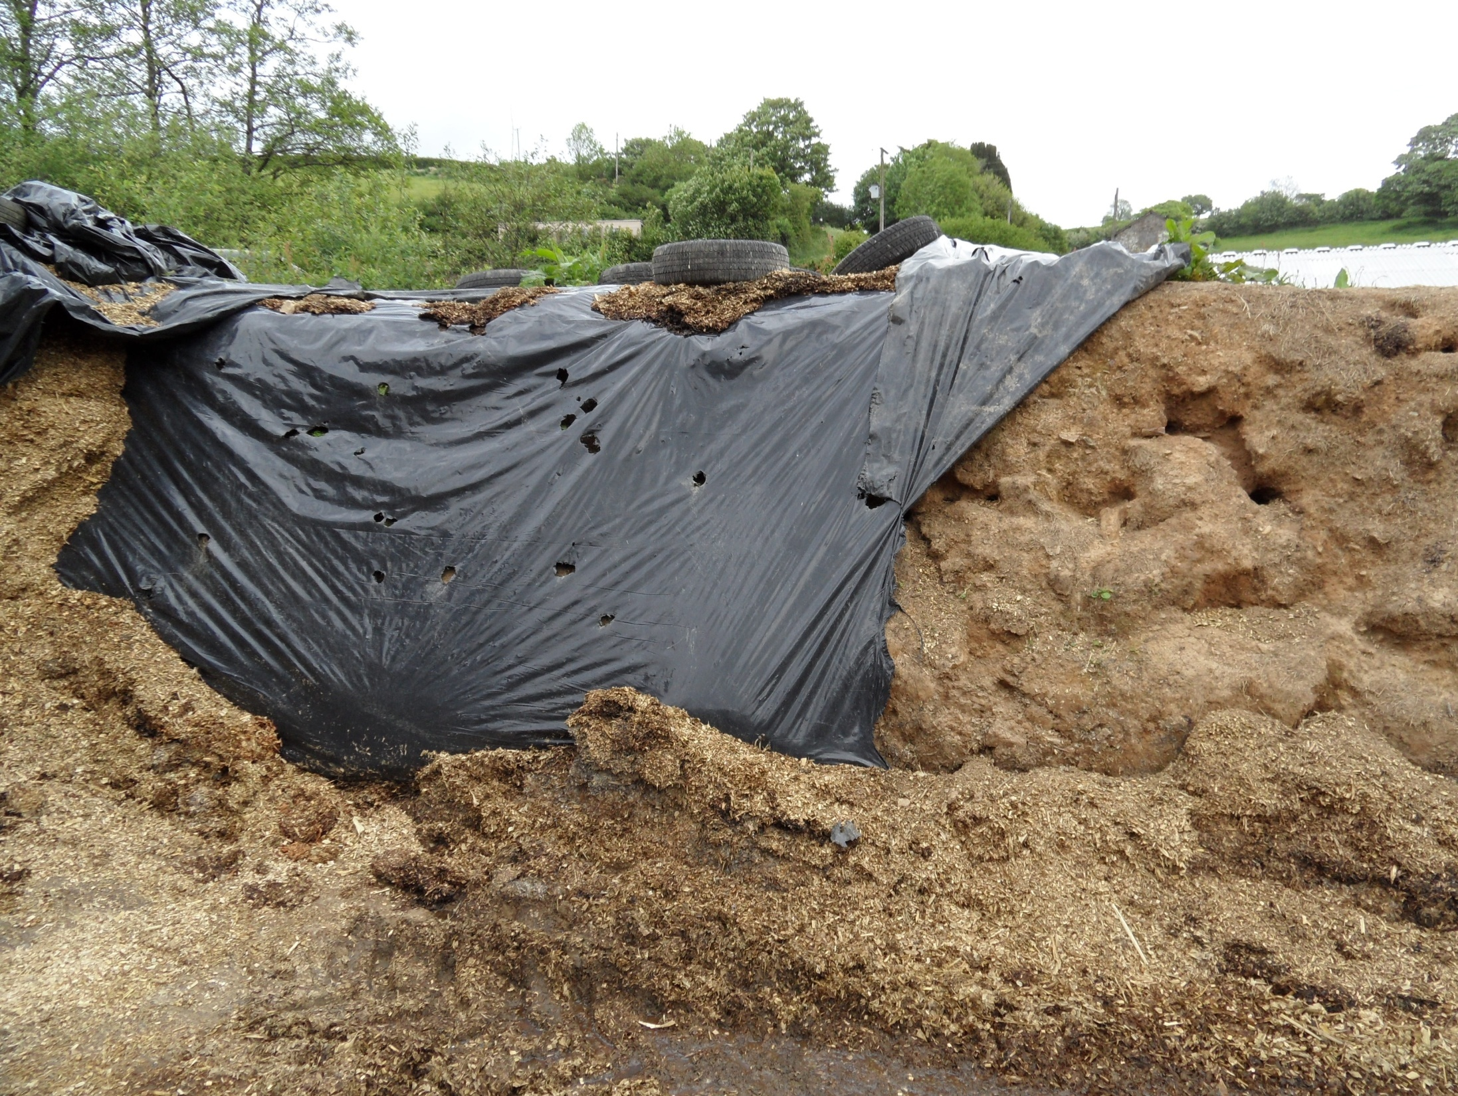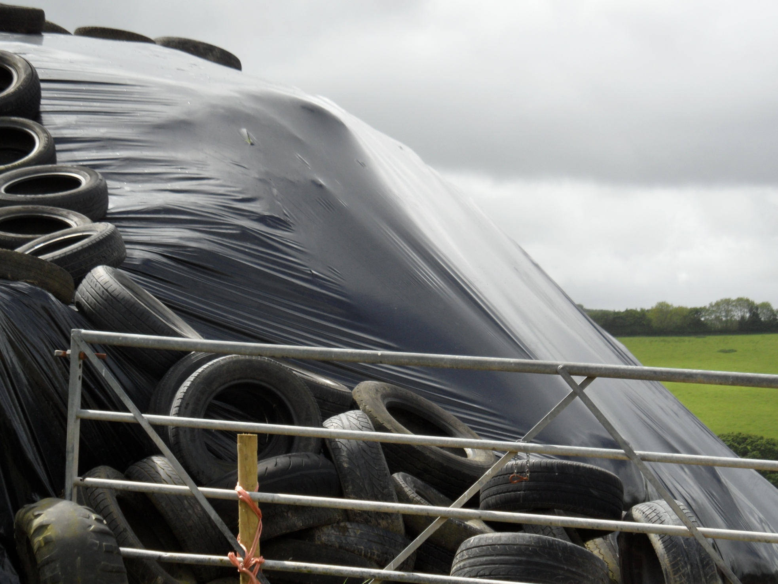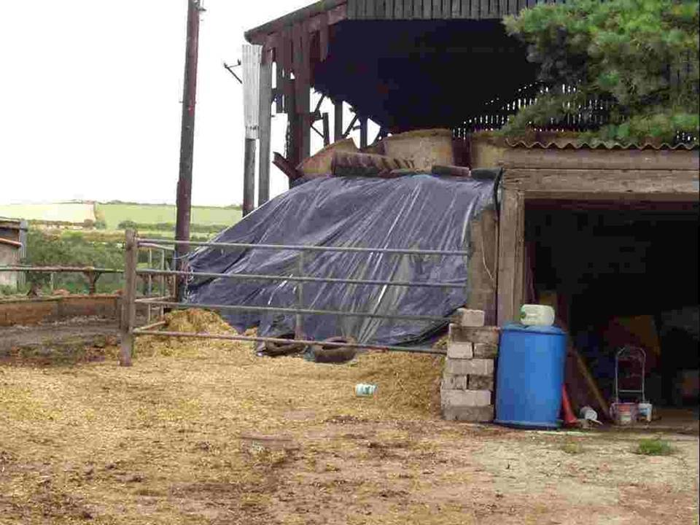
Vermin holes in earth bank clamp Ramps with no weight and air ingression

Baling silage

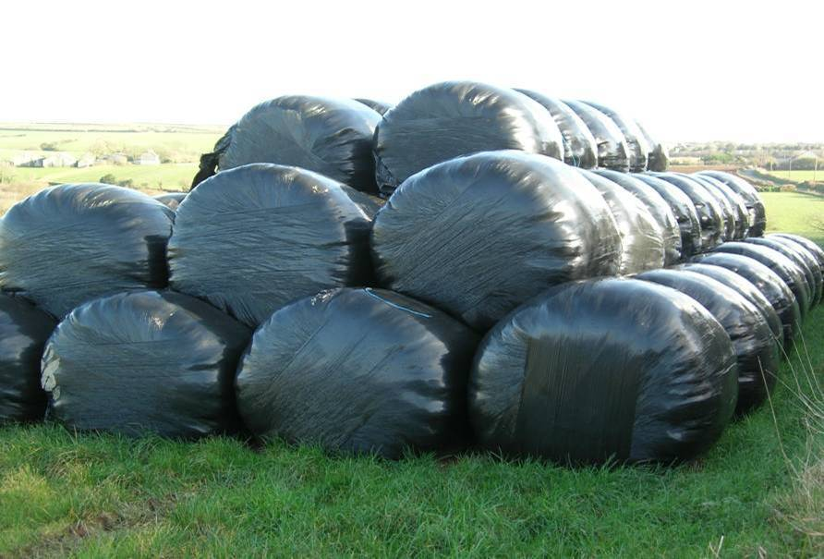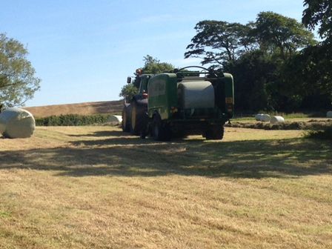

Silage can be either round or square baled. Baling is a flexible method of harvesting fields at the optimum cutting date. Bales are wilted slightly more to maintain shape and allow better stacking. They are more prone to damage, require plastic disposal and are more labour intensive at feed out. Baling cost is similar to clamp silage. This is a surprise to a lot of farmers but is because the Dry Matter losses in a bale (approx. 10%) are much less than a clamp (approx. 17% upwards). Yes the bale plastic & stacking are more expensive but the losses in fermentation are less. Please use enough layers of wrap (at least 6 layers) and even more on dryer haylage bales. Other things to think about: - is the grass chopped in the baler which allows better compaction and feed out – a square bale ferments better because it compacts more and is easier to break apart.
Face management
Face management is crucial in reducing silage losses and presenting a palatable and nutritious feed.
A smooth well-cut face reduces air being trapped in the forage and better nutrient retention with
less face Dry Matter losses.

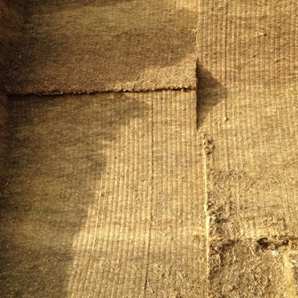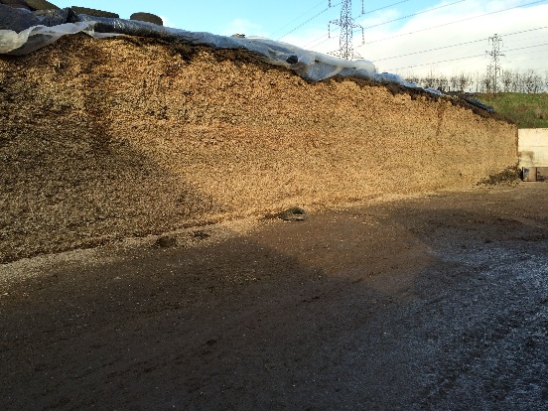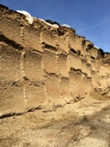

Keep your shear grab sharp. Remember drier forages are harder to cut. See bad examples below.

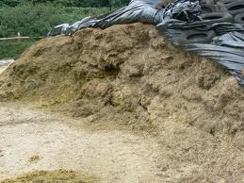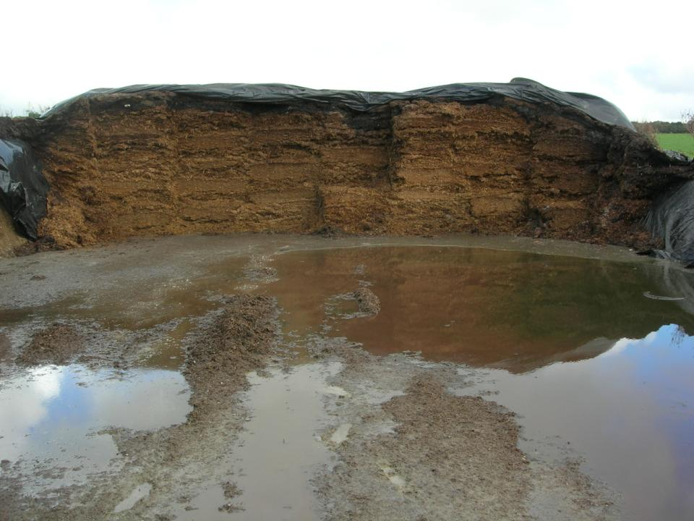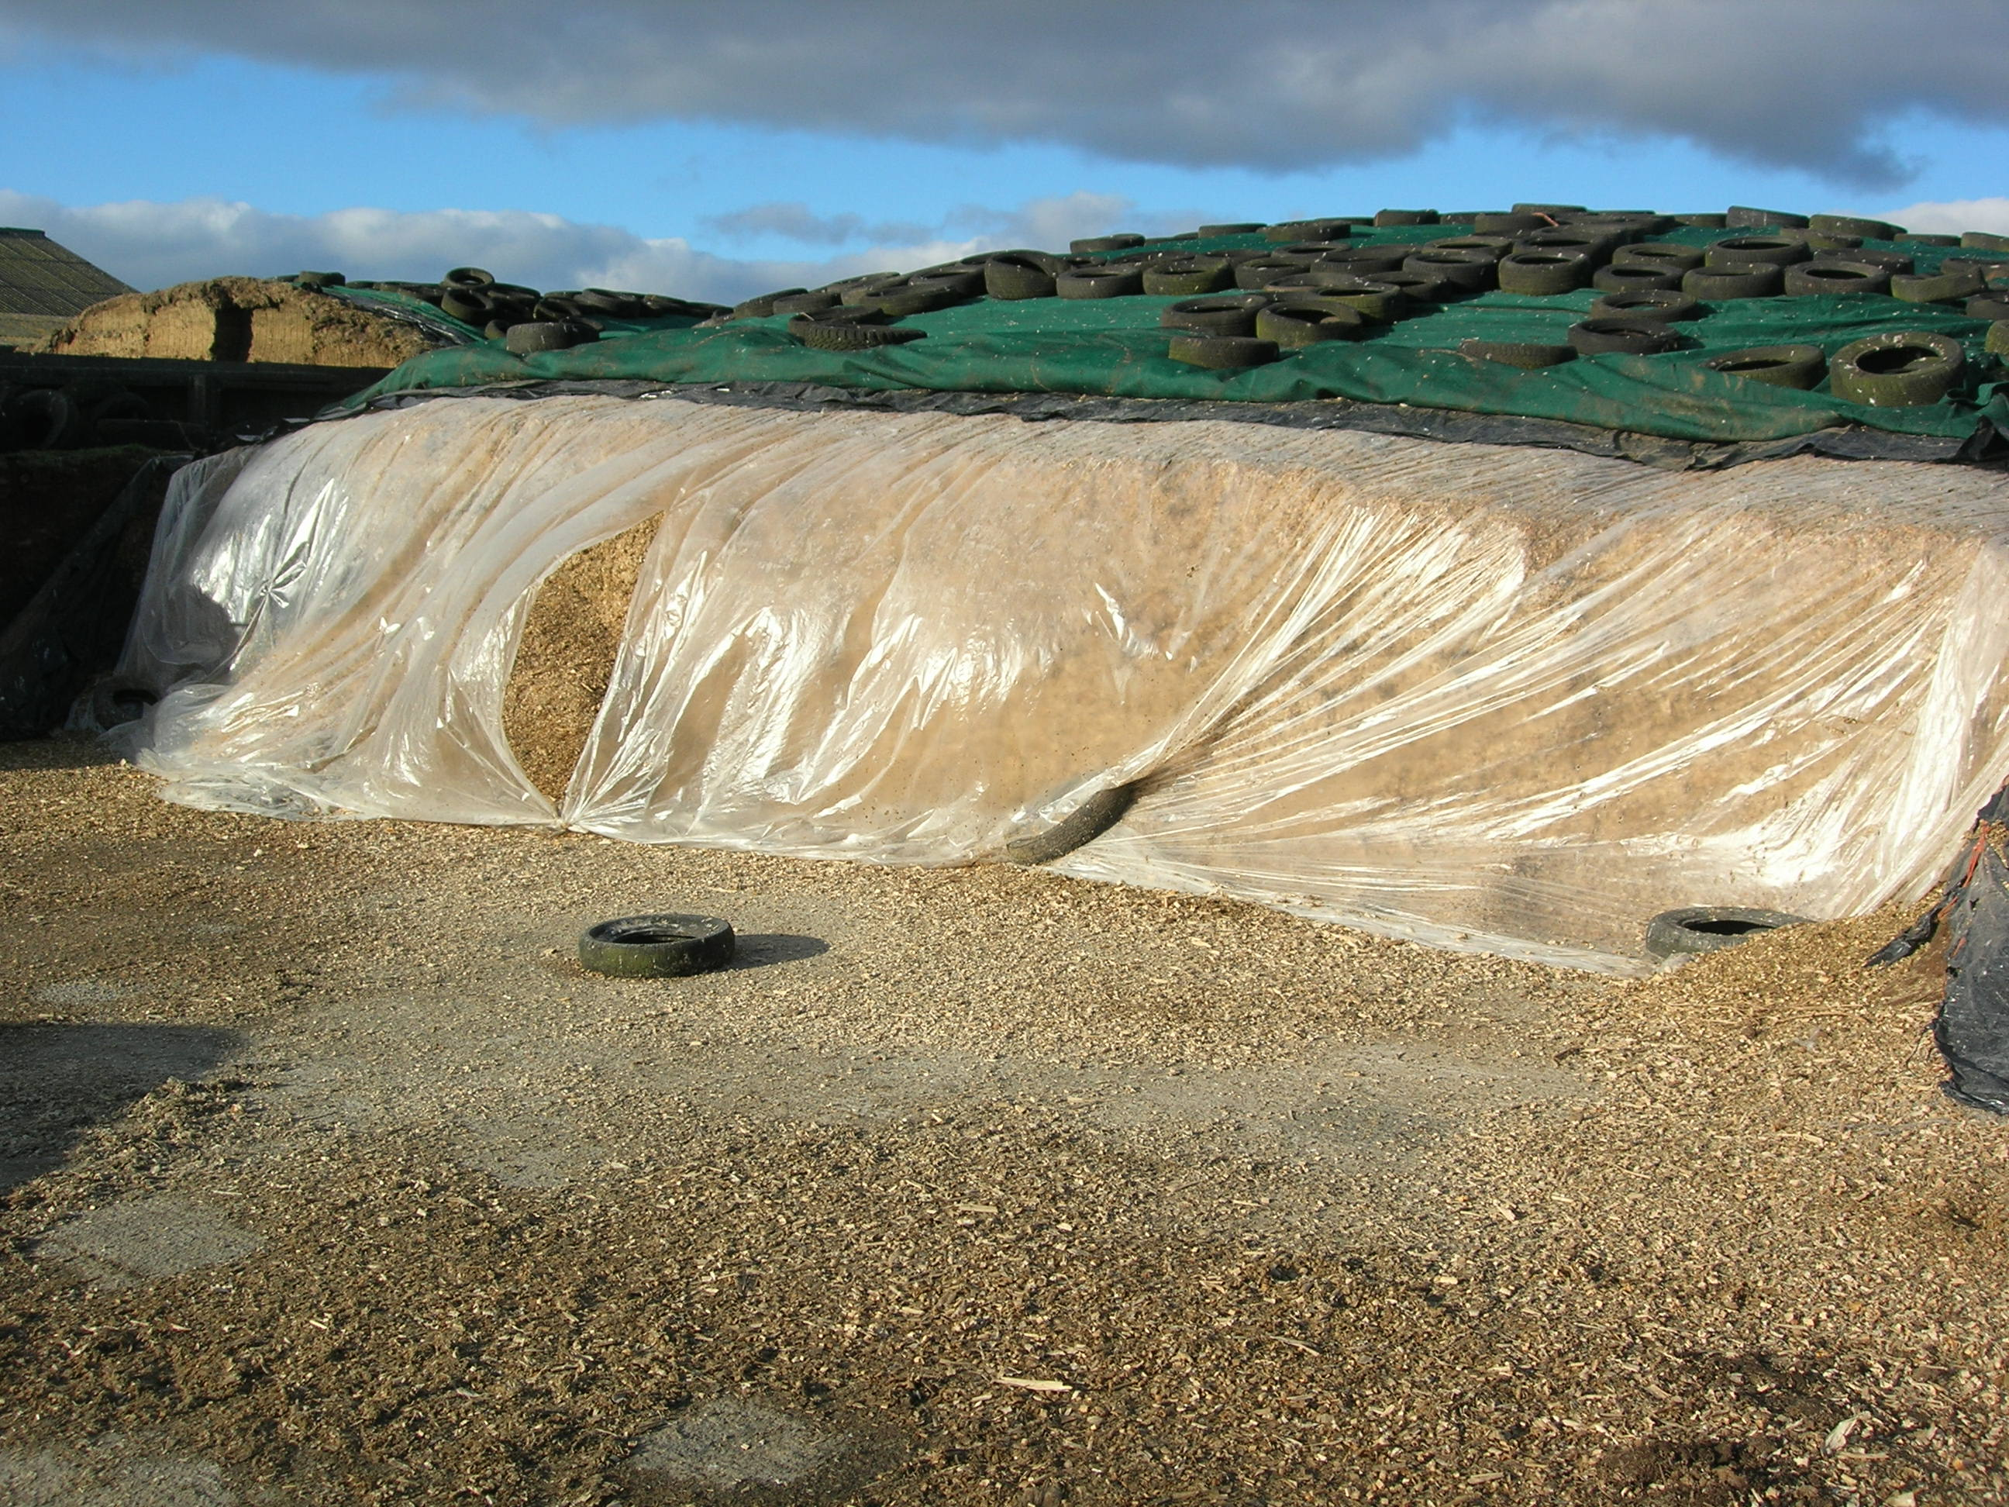
Bad face removal Water spoilage Greenhouse effect

A bad removal of silage will always cause losses. Don’t bucket your silages of the face producing an uneven face. Make sure drainage is good. An old cracked concrete base can always let water back into the silage especially with extra weight of the silage clamped above. Keep the face open. Many farmers pull a sheet down over the face to protect against rain or bird damage. This will cause a greenhouse effect and make heating more probable. Let air onto the face.



